Greater omentum
Fold of peritoneum attached to stomach on its greater curvature

Milky spots
Aggregates of lymphocytes

Policemen of abdomen
Greater Omentum - “Abdominal policeman" of the peritoneal cavity
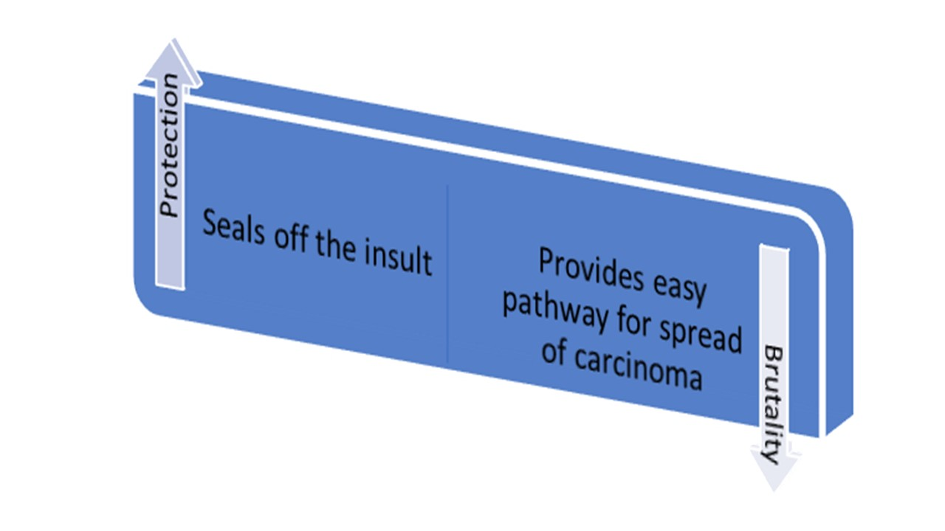
[YOUTUBE] https://youtu.be/Kt8hKkGE8Y8
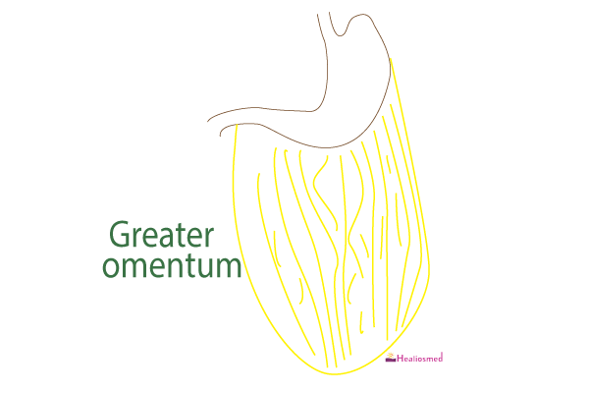

Arterial supply of greater omentum
By Right and left gastroepiploic arteries
and by Branches of Pancreatic Artery
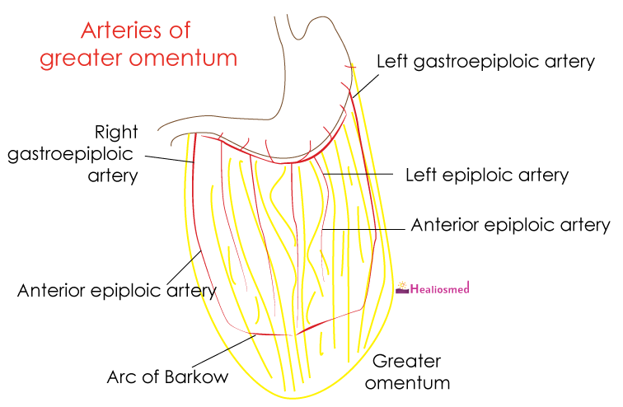
[CLINICAL]Omentopexy
A surgical procedure where greater oemntum is used to
- Fill the gap or defect (as in peptic ulcer perforation)
- To supplement arterial supply (as in thromboangitis obliterans)
- To enhance lymphatic drainage
- To absorb effusions

Embryological basis
Most of the ventral mesentery disappears – except ventral mesogastrium
Fold of peritoneum between anterior abdominal wall and liver forms – falciform ligament
Fold of peritoneum between liver and stomach forms lesser omentum
Fold of dorsal mesogastrium caudal to stomach forms greater omentum
Fold of dorsal mesogastrium between spleen and stomach forms gastroslenic ligament transmitting short gastric arteries
Fold of dorsal mesogastrium between spleen and kidney forms lienorenal ligament and transmits splenic artery

___MCQ_START___
Milky spots in greater omentum are
- Aggregation of macrophages[CORRECT]
- Collection of lymph
- Aggregation of milk
- Aggregation of chyle
____
All of the following arteries are present in greater omentum except
- Left gastric artery[CORRECT]
- Left gastroepiploic artery
- Anterior epiploic artery
- Right gastroepiploic artery
___MCQ_END___

